Experiment 1 - BFS for Emergency Facility Navigation
Application: Finding a route through a hospital or emergency facility.
Question
Develop a Python-based navigation system for an emergency response team operating inside a hospital represented as an unweighted graph. Rooms and junctions are vertices, while accessible corridors are edges. Implement Breadth-First Search (BFS) to identify the route from the emergency entrance to a designated critical-care unit.
The program must:
- Represent the hospital layout as an adjacency list.
- Accept the source and destination nodes.
- Find and display the shortest route in terms of the number of corridors traversed.

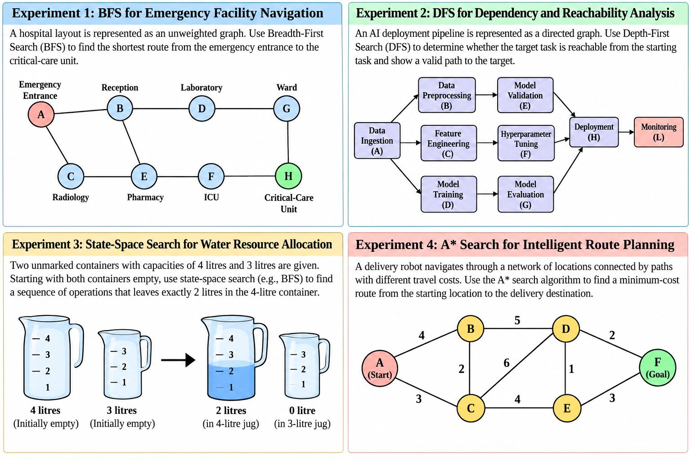
- 2)Report the number of nodes explored and explain how BFS guarantees a shortest path in an unweighted graph.

2) Experiment 2 - DFS for Dependency and Reachability Analysis
Application: Analysing dependencies in an AI software pipeline.
Question
An AI deployment pipeline consists of interconnected processing tasks, where each task depends on one or more downstream tasks. Model the pipeline as a directed graph and implement Depth-First Search (DFS) in Python to determine whether a specified target task is reachable from a given starting task.
The program must:
- Represent the pipeline using a directed adjacency list.
- Accept a starting task and a target task.
- Display the DFS traversal order and determine whether the target is reachable.
- Reconstruct a valid path to the target, if one exists.
- Explain how visited-node tracking prevents repeated exploration and how DFS behaves when the graph contains cycles.

Experiment 3 - State-Space Search for Water Resource Allocation
Application: Measuring a target quantity using containers with fixed capacities.
Question
Design a Python-based state-space search solution for a water allocation problem involving two unmarked containers with capacities of 4 litres and 3 litres. Starting with both containers empty, determine a sequence of valid operations that leaves exactly 2 litres in the 4-litre container.
The program must:
- Represent each state as the quantities of water in both containers.
- Define the legal actions: fill, empty and transfer water between containers.
- Search the state space using BFS and identify a valid solution.
- Display the sequence of states and actions from the initial state to the goal.
- Explain how state representation, goal testing and repeated-state detection affect the search.
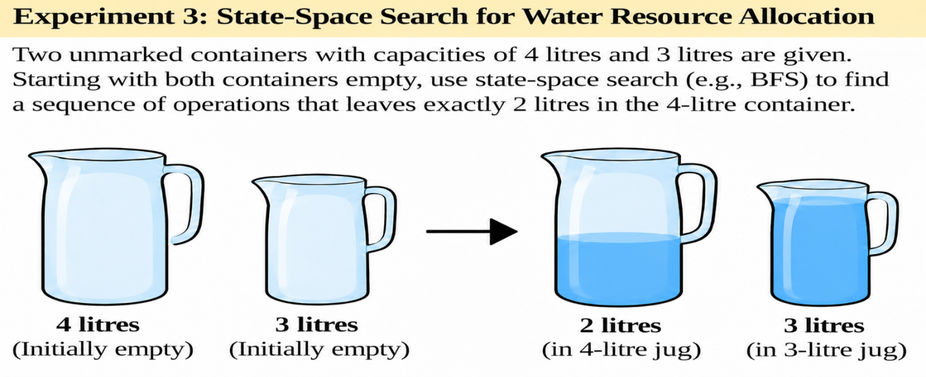

Experiment 4 - A* Search for Intelligent Route Planning
Application: Route planning for an autonomous delivery robot.
Question
Develop an intelligent route-planning system for an autonomous delivery robot navigating a network of locations connected by paths with different travel costs. Implement the A* search algorithm in Python to find a minimum-cost route from a specified starting location to a delivery destination.
The program must:
- Represent the environment as a weighted graph.
- Assign a heuristic estimate \(h(n)\) to each node and calculate the accumulated path cost \(g(n)\).
- Use \(f(n)=g(n)+h(n)\) to determine which node to explore next.
- Display the selected route, total path cost and node expansion order.
- Explain how heuristic quality affects search efficiency and why an admissible heuristic matters for optimality.

Heuristic values.
Node | h(n)
A | 6
B | 4
C | 5
D | 2
E | 3
F | 0

